AN ESSAY FOR BUSINESS LEADERS

AI Has Left
the Chat Window
  - From learning machines to autonomous workers: why the next competitive advantage will depend on authority, physical capability and control over where intelligence runs.
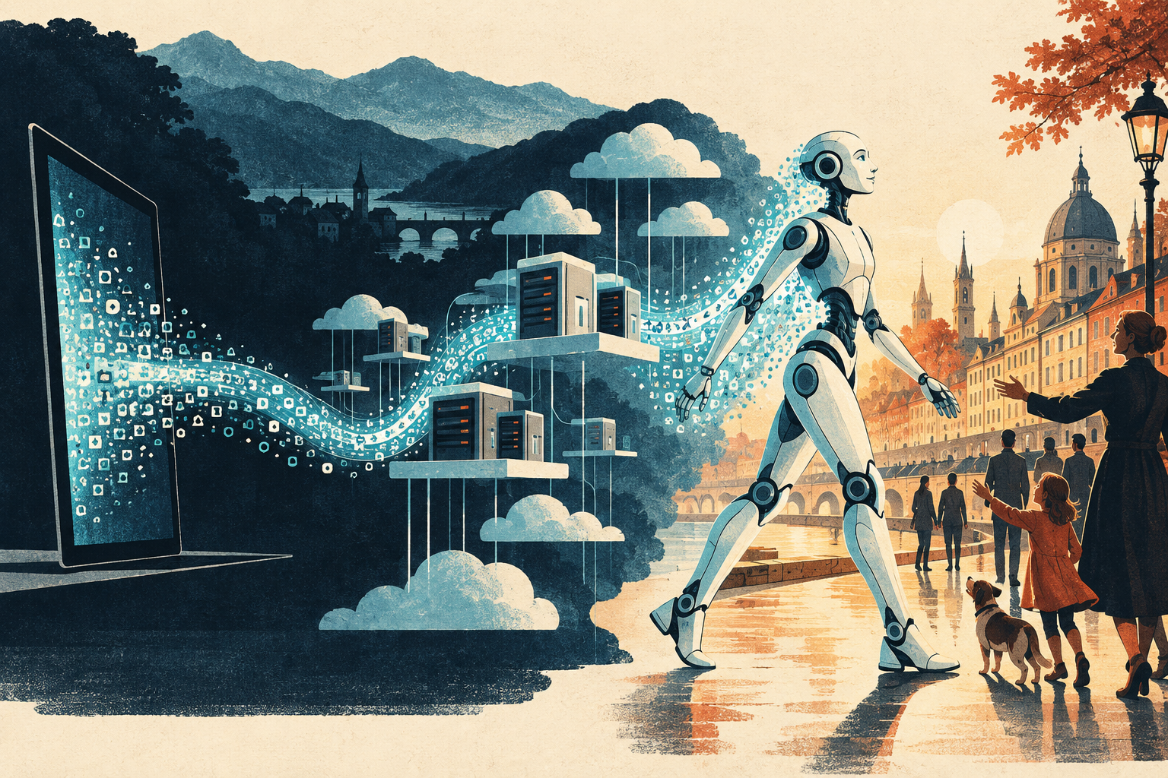
Figure 1 · From digital output to action in the world. AI-generated editorial illustration.
9 SEPTEMBER 2026

Management Summary
AI is becoming an operational capability: systems can increasingly carry out work, observe results and adjust their next step. For executives, the opportunity is greater productivity; the accompanying risk is that a mistaken answer can become a real transaction. Expand useful automation while keeping authority and control aligned.
The adoption gap is the immediate issue. Businesses can deploy agents through existing browser interfaces before they redesign their back-office systems. MCP and other agent protocols provide structured connections, but adoption alone does not resolve permissions or accountability. Browser automation may therefore advance faster than the controls needed to govern it. Incidents could accelerate demand for digital trust services; this is a strategic scenario, not an inevitable sequence.
Access must translate into bounded authority. Permission to manage social posts should never imply permission to transfer money from another browser tab. Identify who the agent represents, restrict its permitted actions and require approval tied to the exact consequential transaction. Signatures help preserve evidence of intent; effective access controls, data validation and fraud detection must support them.
Start with internal workflows where scope and results can be checked. Assign an owner, set limits and provide an escalation path. Retain protected evidence of authorization and execution, with proportionate privacy controls. Measure completed work, errors and the total cost of operation.
Keep deployment choices open. Use local or privately controlled processing where confidentiality, connectivity or economics justify it. Assess the complete path of data and execution: a local interface can still depend on a remote model. Preserve reusable knowledge and the ability to change providers. Open models expand options, but the forecast that an AI server becomes as ordinary as a notebook within two years remains a bet.
Prepare for physical automation without assuming human equivalence. Robotics extends the same questions of delegation and proof into the physical world, adding safety, energy and reliability constraints. Selected AI milestones suggest shorter application cycles, but no universal timetable. The management decision is immediate: fund useful automation and its trust controls together, before a disputed action exposes the gap.

The revolution is becoming operational
A software system receives an assignment. It opens a project, changes the code, runs a test and reads the failure message. Then it tries again. When OpenAI introduced its cloud-based Codex agent in May 2025, this was already a product capability: work on a codebase inside an isolated environment, execute commands and present changes for review. The important development was that a model’s output could trigger an action—and the outcome could guide its next attempt. ^{[1]}
For business leaders, that feedback loop changes the investment question. The opportunity expands from producing useful answers to completing useful work. It also expands the consequences of failure: an inaccurate sentence can become an incorrect purchase, an unauthorized data transfer or, eventually, a physical action.
The foundations took decades to assemble. McCulloch and Pitts described mathematical artificial neurons in 1943. Rosenblatt’s perceptron, described in 1958, learned simple distinctions from examples. Arthur Samuel’s 1959 paper demonstrated learning in a working checkers program—63 years before ChatGPT. Neural networks were part of machine learning’s early history, not a later replacement for it. ^{[2]}, ^{[3]}, ^{[4]}
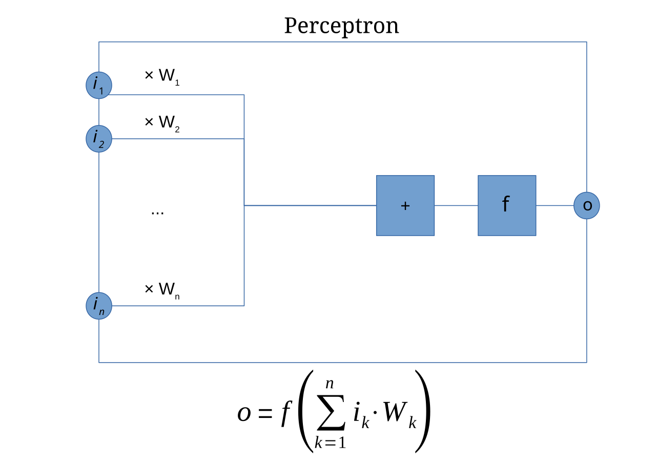
Figure 2 · A perceptron combines weighted inputs to produce an output. Diagram by Mat the w, based on Paskari; CC BY-SA 3.0. Full attribution and source link in the image credits.

Scale met a usable interface
A major obstacle was training networks with internal layers. An influential 1986 Nature paper explained how to propagate errors backwards through a network and adjust its connection weights. By 1998, LeCun and colleagues described neural systems for recognizing handwriting and reading bank checks. In 2012, AlexNet’s decisive ImageNet result showed what large datasets, graphics processors and deep networks could accomplish together. Its top-five error rate was 15.3%, against 26.2% for the runner-up. ^{[5]}, ^{[6]}, ^{[7]}
The Transformer architecture arrived in 2017. Its attention mechanism processes relationships across a sequence, and its training design made effective use of parallel computation. GPT followed in 2018; GPT-2 reached roughly 1.5 billion parameters in 2019. Parameters are the adjustable numbers learned during training. The basic task was deceptively simple: predict the next token—a piece of text—from the preceding context. At sufficient scale, learning that task supported capabilities such as summarization and question answering. ^{[8]}, ^{[9]}, ^{[10]}
GPT-3 expanded to 175 billion parameters in 2020. A striking result was that a few examples in the prompt could guide a new task without changing the model’s weights. Its paper also tested elementary arithmetic. This is more precise than saying GPT-2 suddenly discovered mathematics and GPT-3 invented specialization: task-specific training already existed. GPT-3 demonstrated how much adaptation could happen inside the conversation itself. Size was powerful, but not sufficient. The 2022 Chinchilla research showed that balancing model size with training data could beat much larger models on numerous evaluations. ^{[11]}, ^{[12]}
Then, on 30 November 2022, ChatGPT gave the technology an accessible conversational interface. Additional training using human demonstrations and feedback helped it follow instructions. The commercial significance was immediate in principle: users could describe a goal, inspect an answer and refine the request in ordinary language. Better interaction and better alignment with user intent made capability easier to put to work. ^{[13]}, ^{[14]}

From answering to doing
The next gains came from how systems approached a task. Research on chain-of-thought prompting showed that examples containing intermediate steps could improve performance on certain reasoning problems. Later, OpenAI’s o1 work demonstrated gains from additional training and more computation while solving a problem. These developments made effort at the time of use another lever alongside model size and training data. They did not make every long answer correct. ^{[15]}, ^{[16]}
Systems also became better at selecting relevant documents, retaining progress and checking results. “Context engineering” means organizing the information available to a model. Evaluation loops can ask for revisions, run a test or compare an output with a requirement. These are system-level improvements: a better answer after feedback does not mean the model has permanently retrained itself. A passing test supplies evidence within its scope; a confident self-assessment does not provide the same assurance. ^{[17]}, ^{[18]}
Software created a direct route from language to action. Code is text that another program can execute. OpenAI’s original Codex research in 2021 explored generating working programs; the 2022 ReAct paper investigated combining reasoning with actions and their results. Anthropic introduced Claude Code in February 2025, enabling developers to delegate coding tasks through a terminal interface. An agent is the wider system that combines a model, tools, instructions and a feedback loop. Its permissions determine what it can actually do. ^{[19]}, ^{[20]}, ^{[21]}
By 2025, agents could have remote work environments of their own. Cloud-Codex used isolated sandboxes; ChatGPT agent introduced a virtual computer. A dedicated Linux machine for every agent is one possible mental picture, but execution may use replaceable containers or multiple environments, and the model may run elsewhere. This distinction matters: a local terminal does not establish that inference or data processing stays local. The enterprise must understand the full path from instruction to execution. ^{[1]}, ^{[22]}, ^{[23]}
A local terminal does not establish that the model—or the data—stays local.

Peter Müller orders a thousand shoes

Figure 3 · Peter’s fictional shopping disaster: a joke becomes a purchase. AI-generated illustration.
As shopping agents become available, businesses increasingly need to recognize software acting for a customer. Visa’s October 2025 Trusted Agent Protocol announcement illustrates this demand: merchants need a way to distinguish authorized shopping agents from malicious automation. ^{[24]}
Consider a fictional customer, Peter Müller. Browsing shoes, he jokes: “Order me a thousand. I’m a centipede, after all.” His agent treats the first sentence as an instruction and the second as decoration. It completes the purchases. Peter has made a joke; the system has activated a supply chain.
Who pays? Who cancels the orders, handles the returns and absorbs the shipping costs? The answer depends on the jurisdiction, the contract, the authority granted and the conduct of each party. “The AI did it” does not settle whether Peter is bound or whether he can recover losses from a provider. UNCITRAL’s 2024 Model Law on Automated Contracting addresses attribution and unexpected outcomes, but it is a legislative template, not automatically applicable global law. ^{[25]}
Many EU consumer purchases made online carry a 14-day withdrawal right, although properly disclosed return costs can fall on the consumer. Switzerland has no general statutory withdrawal right for ordinary online purchases. Mistake and attribution rules may also matter; under Swiss law, invoking a mistake does not necessarily eliminate liability for resulting losses. Contract formation, return rights and a claim against the agent provider are separate questions. ^{[26]}, ^{[27]}, ^{[28]}

Old trust technology finds a new market
Peter’s practical safeguard starts before checkout: one pair, a maximum of CHF 150, a named seller if required, and no additional orders without approval. Systems outside the language model can enforce those limits. A signed mandate can establish what was authorized. It cannot repair a mistaken instruction that Peter knowingly approved without reading.
This is where electronic signatures, seals and timestamps acquire renewed relevance. The EU’s eIDAS framework dates to 2014. A qualified electronic signature has the equivalent legal effect of a handwritten signature; a qualified electronic seal carries a presumption of integrity and correct origin. Neither establishes that every statement is true or that a purchase is authorized. Under this framework, signatures relate to natural persons and seals to legal persons. Giving software a credential does not make it a legal person. ^{[29]}
The comeback thesis is a demand thesis: autonomous transactions create more occasions to verify identity, authority and provenance. Google’s Agent Payments Protocol, announced in September 2025, uses cryptographically signed mandates to record intent and transaction approvals. These mechanisms do not all require qualified electronic signatures. They do show why infrastructure developed long before today’s agents can become commercially valuable in the agent economy. ^{[30]}
For executives, the opportunity extends beyond issuing credentials. Businesses need services that validate them: Is the issuer trusted? Is the mandate still valid? Does it cover this amount, this recipient and this action? Those checks should produce evidence that counterparties can verify. The more autonomy a company delegates, the more valuable clearly bounded authority becomes.
Autonomy creates demand for a very old idea: prove that you are entitled to act.

The next interface has a body
The transition into robotics is already under way. Google DeepMind’s RT-2 research in 2023 connected visual and language information with robot actions. Gemini Robotics followed in 2025. Its 2026 successor reported progress in whole-body control and multi-step tasks, while acknowledging difficult areas such as dexterous manipulation. These are demonstrations of capabilities under specified conditions, not proof of a universally reliable household worker. ^{[31]}, ^{[32]}, ^{[33]}
We have spent decades preparing people to work digitally: write documents, interpret information and operate software. AI is taking on parts of that work. Physical environments add different requirements. Cameras, microphones, touch sensors and other instruments must inform decisions that become controlled movements. Even artificial smell is an active research area: a 2022 study combined touch and smell sensing in a mechanical hand. No single model has to process every sense. ^{[34]}
Local processing is especially consequential here. DeepMind’s Gemini Robotics On-Device, introduced in June 2025, could operate without a data connection. The remaining challenge includes the entire machine: perception, motion, safety, maintenance and energy. Imagine a capable robot that reliably alternates work and charging over a 24-hour daily cycle. That would be a meaningful operating model, not a scientific threshold for intelligence. Unitree’s published G1 specification, for comparison, lists approximately two hours of battery life, depending on conditions. ^{[35]}, ^{[36]}
A Transformer with senses, memory, internal priorities and a body is a provocative analogy. It is not an established description of a human being. The brain is not demonstrably an LLM, language is not identical to thought, and emotions cannot be reduced to a simple deterministic limbic controller. Robotics performance and battery endurance establish neither consciousness nor personhood. For business, the nearer question is which physical tasks these systems can perform reliably and economically. ^{[37]}, ^{[38]}
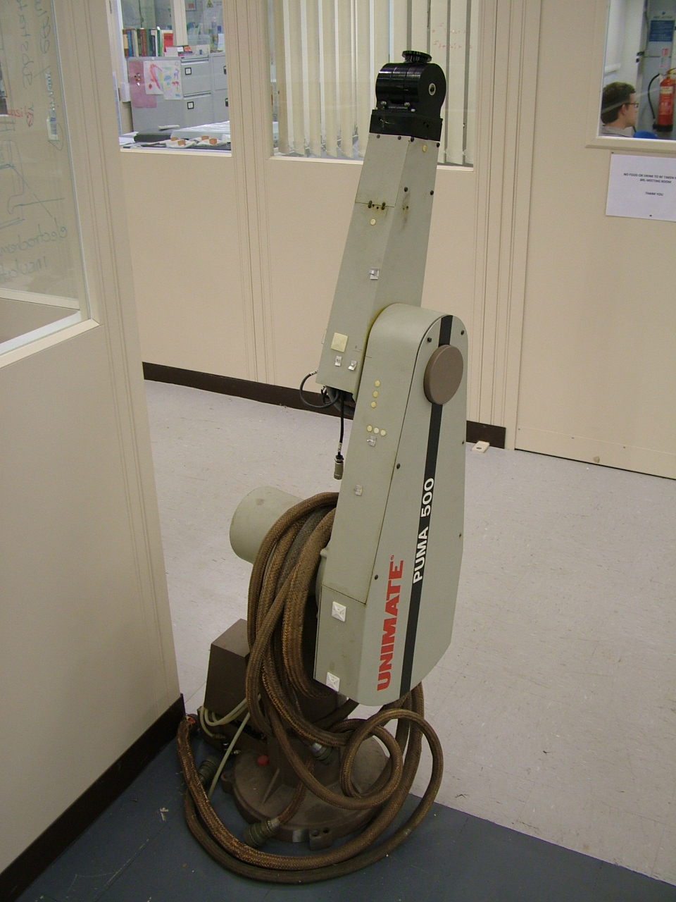
Figure 4 · A classic UNIMATE PUMA arm, photographed in 2010. This is historical robot hardware, not a modern AI agent. Photo: Razor Robotics; CC BY 2.0. Full source in the image credits.

At the kiosk, a robot asks for proof

Figure 5 · A future kiosk transaction: agents exchange evidence of authority. AI-generated illustration of a hypothetical scenario.
Imagine a household robot buying an age-restricted product from a kiosk staffed by another robot. “How old is the person who sent you?” asks the seller. A spoken number would be inadequate. The visitor would need a verifiable age claim and a mandate connecting that customer to this purchase.
One digital building block already exists. The European Commission has described age-verification technology that proves an age threshold without disclosing a person’s precise age or identity. Delegated robot purchases would require additional mechanisms tying that proof to the principal and the transaction. This kiosk is a future scenario, not a description of a fully deployed standard. ^{[39]}
The next question is harder: “If the health authority investigates, can you prove that you delivered it to that person?” The relevant regulator and any legal obligation would depend on the product and jurisdiction; there is no general reporting requirement being asserted here. A secure receipt could record the recipient’s confirmation. Whether the physical handover actually occurred correctly would also depend on the devices and procedure. As the W3C credentials standard makes clear, a verifiable claim is not automatically a true claim. ^{[40]}
The commercial requirement is a chain of accountable delegation, from customer to agent to seller to recipient. The privacy requirement is to disclose only what that transaction needs. Proof of an age threshold should not become a license to expose a complete identity or record someone’s everyday life. Trust infrastructure could become as relevant to physical commerce as it is to digital transactions.

The intervals are compressing
Selected milestones | Period | Interval
Samuel → AlexNet | 1959–2012 | 53 years
AlexNet → ChatGPT | 2012–2022 | 10 years
ChatGPT → Cloud-Codex | Nov 2022–May 2025 | About 2½ years
Cloud agents & local robotics | 2025–2026 | Overlapping wave
Selected dates from the original publications cited in the article. Different kinds of milestones; not a fitted acceleration curve.
The selected milestones tell a striking story. Samuel’s 1959 paper preceded AlexNet by 53 years. AlexNet preceded ChatGPT by a decade. Cloud-Codex arrived roughly two and a half years after ChatGPT. Local robotics models appeared in the same 2025 wave, with further advances in 2026. These events differ in kind and overlap; this is an illustration of accelerating application cycles, not a universal law of progress.
There is also measurable evidence in a narrower domain. METR reported in 2025 that the task horizon of the leading models it studied had doubled roughly every seven months since 2019. This measures the human expert time associated with tasks an agent completes with 50% reliability. It is not a doubling of general intelligence, nor a forecast for robotics. Even with those limits, it suggests that the operational scope of software agents can grow rapidly. ^{[41]}
The outcome remains contingent. Cost, energy, reliability and public acceptance matter. War can destroy infrastructure; vandalism and manipulation can make machines unusable in public spaces. Human destructiveness is a real threat, but not the only obstacle. The pace of technical progress makes institutional choices more urgent: what authority to delegate, how to verify outcomes and which forms of dependency to accept.

Who is actually operating the browser?
Agents can operate the same browser interfaces people use: clicking, typing, opening pages and working inside authenticated sessions. OpenAI’s 2025 ChatGPT agent announcement explicitly described those capabilities, alongside confirmation steps and restrictions on high-risk actions. That changes a fundamental question for online businesses: when activity arrives through a familiar browser, who is actually acting? ^{[22]}
For an e-banking service, a recognized device, valid session and familiar IP address are useful signals. None alone establishes that the customer personally initiated a particular instruction. A human may be operating the browser, an authorized agent may be helping, or automation may have exceeded its mandate. Many agents can share a network address. The relevant question becomes: whose authority covers this specific action?
Imagine a customer who gives an assistant browser access to organize Facebook posts. The customer means one task on one website. The integration grants broader control over a browser profile that also contains an authenticated crypto-exchange session. In this hypothetical case, inadequate isolation and transaction controls allow the agent to move to another tab and withdraw bitcoin. This is a scenario about excessive permissions, not a claim that every agent can bypass financial safeguards. It requires access and controls weak enough to permit the withdrawal.
The customer is understandably bewildered: “I asked you to manage Facebook. I never asked you to move my money.” The gap is between technical access and actual authorization. Convenience and enthusiasm for automation can make broad access feel like a harmless shortcut. Yet an instruction written in a prompt is not an independently enforced permission boundary. A local agent can create the same problem as a cloud agent if both receive excessive rights.
Who absorbs the loss: the customer, agent provider, integration operator or financial service? Applicable law, contracts, authorization evidence and failures by each party matter. EU payment law already recognizes that recorded use of a payment instrument does not necessarily prove authorization or gross negligence. That rule cannot simply be carried over to every bitcoin withdrawal or Swiss banking dispute. The lesson is to preserve the evidence needed to determine responsibility before something goes wrong. ^{[42]}

Make liability part of everyday business judgement
Liability should become ordinary business common sense in automation design. Before giving an agent access, ask what it may do, for whom, on which service, within what limits and for how long. “Manage these Facebook posts” should translate into an enforceable scope—not control over every authenticated service in the browser. Separate browser profiles or execution environments, restricted destinations and service-level permissions can help contain the mandate. A website restriction alone is insufficient if it still permits every action on that site.
This creates a compelling demand for digital trust. The easier it becomes to delegate work, the more valuable an explicit record of delegation becomes. Signed mandates and transaction approvals can bind authority to an action, recipient, amount, document version and expiry time. They can make the chain of responsibility easier to establish. They do not automatically allocate liability or make an unsafe transaction safe. Google’s Agent Payments Protocol illustrates this move towards cryptographically recorded intent and approvals. ^{[30]}
For business leaders, the instruction is practical: sign consequential documents and capture verifiable approvals for liability-relevant actions, using the assurance level appropriate to the transaction. Show the person exactly what they are approving through a protected channel. An agent should not be able to silently change the recipient after approval. EU payment authentication rules already embody this principle through dynamic linking to the amount and payee where required. This is transaction-specific authorization, not merely another login. ^{[43]}
Use renewed identity verification when identity assurance needs refreshing, and fresh authentication when a consequential action requires it. Add proportionate behavioral analysis to flag unusual recipients, destinations or activity. Validate the underlying data, credentials, certificates and mandate before execution. Behavioral signals guide scrutiny; they do not conclusively identify a human or establish consent. A stronger identity check still needs an approval tied to the action being taken.
The simple-signature shortcut has reached its limit. Electronic signatures have not lost their legal value: eIDAS explicitly protects their admissibility and gives qualified signatures the effect of handwritten signatures. What fails is treating a signature image, an IP address or an authenticated session as complete proof of informed intent. The valuable evidence connects identity, authority, approved content and the action actually executed. ^{[29]}

The transition will arrive before the controls
MCP connects AI applications to business tools and data. Such connections can bypass screens, but their availability does not mean every organization has integrated them or established transaction-level authority. The transition can combine direct tool connections, purpose-built agent services and browser automation. ^{[44]}
The near-term scenario is a familiar one. Businesses want automation before they have redesigned their systems. Agents operate existing interfaces in an RPA-like fashion: opening pages, entering data and pressing buttons. The process accelerates while its permission model remains unchanged. Software still appears as the customer’s authenticated session. This is an adoption scenario, not evidence that agent protocols have failed.
The uncomfortable strategic hypothesis is that control investment may lag behind automation. An unauthorized transfer or disputed order exposes missing evidence: who delegated the task, what limits applied and which action was approved? Such incidents could accelerate demand for agent identities, signed mandates, transaction-specific approvals, stronger fraud detection and reliable validation. Signatures support that evidence; enforced permissions must still prevent unauthorized actions.
Business leaders should build that chain before a loss forces the issue. Start internally with bounded workflows. Identify the agent and its principal, enforce permissions by service and action, and bind consequential approvals to the exact transaction. Refresh identity assurance or authentication when needed. Use behavioral analysis to flag anomalies, validate data and credentials, and retain protected records of authorization and execution. Make responsibility traceable across the customer, agent operator and service provider.
Keep the underlying infrastructure portable. Open models can support independent deployment, although strong benchmark results do not imply equal capability across all tasks, and open weights are not identical to fully open-source AI. ^{[45]}, ^{[46]} The two-year bet remains that an AI server could become an ordinary work resource, much like a notebook. The lasting investment is in reusable knowledge, controlled delegation and trustworthy processes.
The likely tension is between the speed of automation and the speed of accountability. Browser agents can bridge the integration gap while creating demand for the trust infrastructure that more mature agent workflows need. Do not wait for the first disputed transaction to discover that browser access was mistaken for permission to act.

Sources and image credits
Numbered citations link to research papers, official announcements, legal texts and standards. Vendor claims are identified in the article. Future scenarios and strategic recommendations are editorial analysis. Sources checked as of 9 September 2026.
- OpenAI: Introducing Codex, 2025 · openai.com
- McCulloch and Pitts, 1943 · link.springer.com
- Rosenblatt, 1958 · homepages.math.uic.edu
- Samuel, 1959 · people.csail.mit.edu
- Rumelhart et al., 1986 · www.nature.com
- LeCun et al., 1998 · yann.lecun.com
- Krizhevsky et al., 2012 · proceedings.neurips.cc
- Vaswani et al., 2017 · arxiv.org
- Radford et al., 2018 · cdn.openai.com
- Radford et al., 2019 · cdn.openai.com
- Brown et al., 2020 · arxiv.org
- Hoffmann et al., 2022 · arxiv.org
- OpenAI: Introducing ChatGPT, 2022 · openai.com
- Ouyang et al., 2022 · arxiv.org
- Wei et al., 2022 · arxiv.org
- OpenAI: Learning to reason with LLMs, 2024 · openai.com
- Anthropic: Building effective agents, 2024 · www.anthropic.com
- Anthropic: Effective context engineering, 2025 · www.anthropic.com
- Chen et al., 2021 · arxiv.org
- Yao et al., 2022 · arxiv.org
- Anthropic: Claude 3.7 Sonnet and Claude Code, 2025 · www.anthropic.com
- OpenAI: Introducing ChatGPT agent, 2025 · openai.com
- Anthropic: Managed agents, 2026 · www.anthropic.com
- Visa: Trusted Agent Protocol, 2025 · investor.visa.com
- UNCITRAL: Model Law on Automated Contracting, 2024 · uncitral.un.org
- Your Europe: Returns and withdrawal · europa.eu
- SECO: Withdrawal rights · www.kmu.admin.ch
- Swiss Code of Obligations: Articles 23–26 and 32 onward · www.fedlex.admin.ch
- eIDAS: Articles 3, 25 and 35 · eur-lex.europa.eu
- Google Cloud: Agent Payments Protocol, 2025 · cloud.google.com
- Brohan et al.: RT-2, 2023 · arxiv.org
- DeepMind: Gemini Robotics, 2025 · deepmind.google
- DeepMind: Gemini Robotics 2, 2026 · deepmind.google
- Liu et al., 2022 · pubmed.ncbi.nlm.nih.gov
- DeepMind: Gemini Robotics On-Device, 2025 · deepmind.google
- Unitree: G1 specifications · www.unitree.com
- Varley et al., 2005 · www.pnas.org
- LeDoux, 2012 · www.cell.com
- European Commission: Age-verification technologies, April 2026 · digital-strategy.ec.europa.eu
- W3C: Verifiable Credentials Data Model 2.0 · www.w3.org
- Kwa et al., 2025 · arxiv.org
- PSD2: Article 72 · eur-lex.europa.eu
- Regulation (EU) 2018/389: Article 5 · eur-lex.europa.eu
- MCP: Introduction · modelcontextprotocol.io
- DeepSeek: R1, 2025 · arxiv.org
- Open Source Initiative: Open Source AI Definition 1.0 · opensource.org

Image credits
Figures 1, 3 and 5: AI-generated editorial illustrations created for this article. Fictional scenes, not documentary photographs.
Figure 2: Mat the w, based on a raster image by Paskari: Perceptron.svg. Wikimedia Commons; text-to-path version by Lovasoa. Original and version history. Licensed under CC BY-SA 3.0. Reproduced without content changes; rasterized and scaled for Word. This license applies to the diagram.
Figure 4: Razor Robotics: UNIMATE PUMA 200 Robot Arm, photographed 4 August 2010; the housing itself is labelled PUMA 500. Original on Wikimedia Commons, originally published on Flickr. Licensed under CC BY 2.0. Reproduced without content changes and scaled.

AI — artificial intelligence: computer systems that perform tasks such as recognizing patterns, generating language or selecting actions.
Agent — a system combining an AI model, tools and a feedback loop to pursue a task within assigned permissions.
MCP — Model Context Protocol: a standard for connecting AI applications to external tools and data. It does not by itself establish a user’s authority for a transaction.
Protocol — agreed rules and message formats that let software systems communicate.
Perceptron — an early, simple neural model that combines weighted inputs to classify an example.
Neural network — a model of connected computational units whose adjustable numerical weights are learned from examples.
Machine learning — methods that learn patterns from data rather than relying only on explicitly programmed rules.
Top-five error rate — the share of test images whose correct label is absent from the model’s five highest-ranked predictions.
Transformer — a neural-network architecture using attention to combine information from relevant parts of its input.
GPT — Generative Pre-trained Transformer: a family of language models trained to generate text using the Transformer architecture.
Parameters or weights — numerical values adjusted during training; their count describes model size, not intelligence by itself.
Token — a unit processed by a language model, often a word fragment or punctuation mark; it is not necessarily a whole word.
Prompt — the instruction and other input supplied to a model to guide its response.
Chain-of-thought — intermediate reasoning steps used when approaching a problem; such steps do not guarantee a correct result.
Terminal or shell interface — a text-based interface for issuing commands to a computer.
Sandbox — a restricted execution environment intended to limit a program’s access and effects.
Container — a packaged application environment that typically shares the host’s operating-system kernel; it is not necessarily a separate virtual machine.
Inference — running a trained model to produce outputs, rather than changing its learned parameters through training.
UNCITRAL — United Nations Commission on International Trade Law, which develops legal texts to help harmonize international trade law.
eIDAS — electronic IDentification, Authentication and trust Services: the EU framework for electronic identification and trust services.
Qualified electronic signature — an EU legal category requiring a qualified certificate and qualified signature-creation device, with the legal effect of a handwritten signature.
Qualified electronic seal — an EU trust mechanism for legal persons that provides presumptions about the origin and integrity of data.
Provenance — the origin and relevant history of information, including who issued or changed it.
Cryptographically signed mandate — a digitally signed record of delegated authority, designed to make its origin and subsequent alteration verifiable.
Credential — an issued statement about an identity, attribute or entitlement, whose issuer and validity can be checked.
RT-2 — Robotics Transformer 2: a model that connects visual and language input with robot actions.
LLM — large language model: a model trained on substantial amounts of language data to process and generate text.
Principal — the person or organization on whose behalf an agent acts.
W3C — World Wide Web Consortium, the international organization that develops standards for the web.
METR — Model Evaluation & Threat Research, an organization that evaluates AI capabilities and risks.
Authenticated session — an ongoing interaction accepted by a service after login; it does not establish approval for every later action.
IP — Internet Protocol. An IP address identifies a network endpoint; it is not reliable proof of a particular person’s identity.
Dynamic linking — binding payment authentication to a specific amount and recipient so that changing either invalidates that authentication.
RPA — robotic process automation: software that performs tasks through existing interfaces, often by reproducing clicks, typing and other predefined steps.
Open weights — model parameters made available under a licence; this does not necessarily include the training data, code or freedoms required for fully open-source AI.

